consulting

sales

staffing

support

simplifying **IT**

consulting

technology

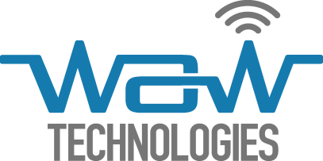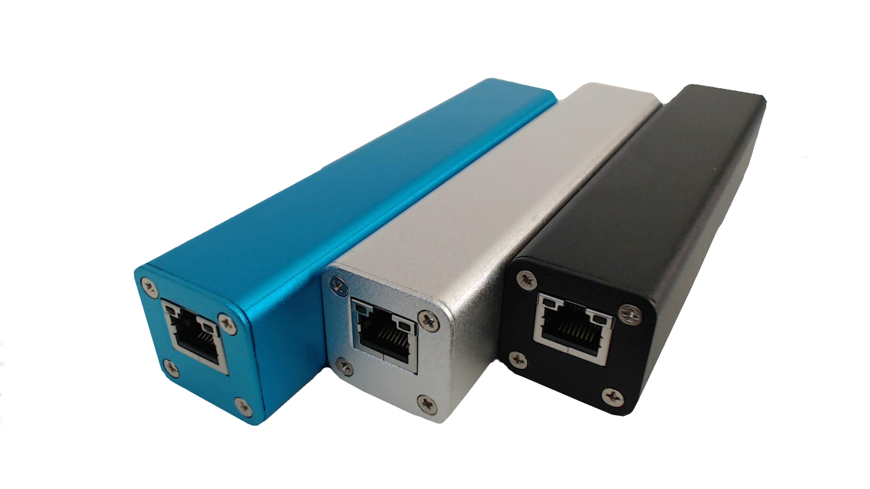

* **Advanced Threat Detection**
  + internal IDS
  + data leakage
  + botnet detection
  + worm detection
* **Network Visibility and Security**
  + communication monitoring
  + data leakage
* **Compliance** 
  + (HIPAA, PCI, FISCA, SCADA, ITSG-33)
  + QoS monitoring
* **Network Troubleshooting and Planning**
  + enterprise-wide view of network traffic usage
  + planning for capacity upgrades and elimination of bottlenecks
* **Forensics and Investigations**
  + continuous, flow-based information
  + attack history reconstruction
  + reporting on one, or on multiple users
* **Industry**
  + continuous industrial process monitoring



**NEWT – Network Explorer Wire Tap**

255 Centrum Blvd., Suite 102

Ottawa, Ontario K1E 3W3

613.366.3055 ph / fax

www.wawtechnologies.com

**BENEFITS**

**sophisticated data capture and reporting**

**leveraging of flow data collected at the endpoints**

**visibility into security control failures**

**ability to fill in the gaps left by perimeter security solutions**

**better understanding of network architecture**

**in-depth, enterprise-wide view of network traffic use**

**identification of behavioral-based anomalies**



**delivers continuous flow-based information**

**allows network and security teams to run tailored flow queries**

**eliminates network blind spots**

**brings accountability and measurability to network use**

**maintains the forensically clean state of endpoints**

**conduct security investigations with granularity configurable from entire network visibility to a single user**

**identify problems in a timely manner**

**reconstruct the history of a compromise**



**provides actionable intelligence**

**"plug-and-play" functionality requires no infrastructure changes**

**lower cost unobtrusive alternative to existing enterprise grade solutions**

WAW Technologies’ flagship product, **NEWT**, is an intelligent, small form factor security appliance that can be installed in-line, at the endpoint equipment. It delivers real-time, host-level insight of activities and behaviors for individual workstations, servers and any other IP-based devices on the network.

**NEWT** helps address common network challenges and is fully interoperable with commercial network data collectors such as IsarFlow, Fluke, Cisco, Dartware, AdventNet, Arbor Networks, Plixer, NetFlow Auditor, SolarWinds Orion NTA, etc.

connecting your business to the technology resources you need